**Key Differences:**

1. **Template-driven Forms**:
   * Easier to set up and use for simple forms.
   * Uses Angular directives to bind the form in the template.
   * Requires FormsModule.
2. **Reactive Forms**:
   * Provides more control and flexibility.
   * Uses a model-driven approach to handle form inputs and validation.
   * Requires ReactiveFormsModule.

Both approaches have their use cases, and the choice between them depends on the complexity and specific needs of your form. Template-driven forms are simpler and faster to set up, while reactive forms offer greater control and are better suited for complex form scenarios.

In Angular, there are two primary ways to build forms: Template-driven forms and Reactive forms. Here's a simple example to illustrate the difference between the two approaches:

### Template-driven Form

Template-driven forms rely on Angular directives in the template to create and manage the form. They are easier to use for simple forms but provide less control compared to reactive forms.

#### Example:

1. **app.module.ts** - Import FormsModule

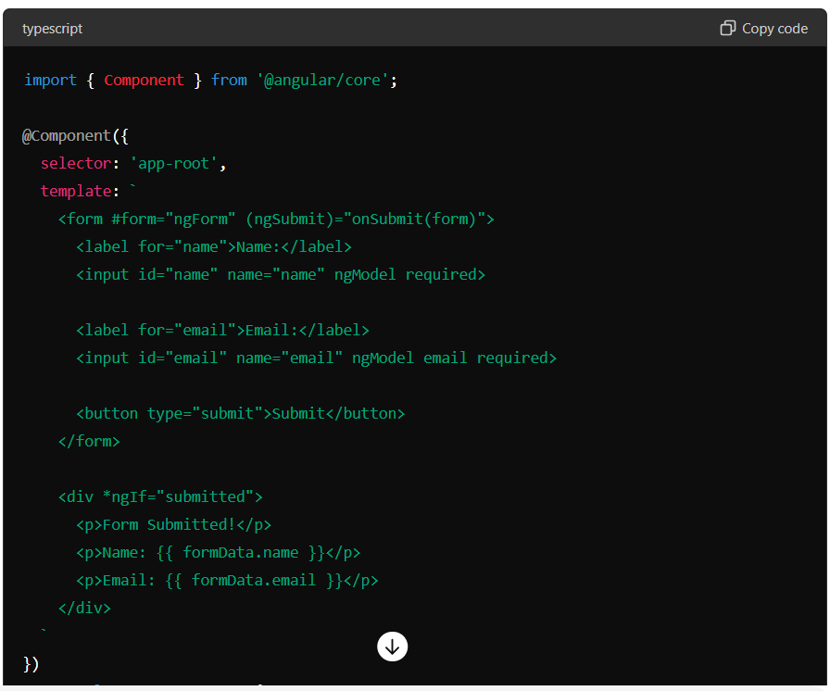

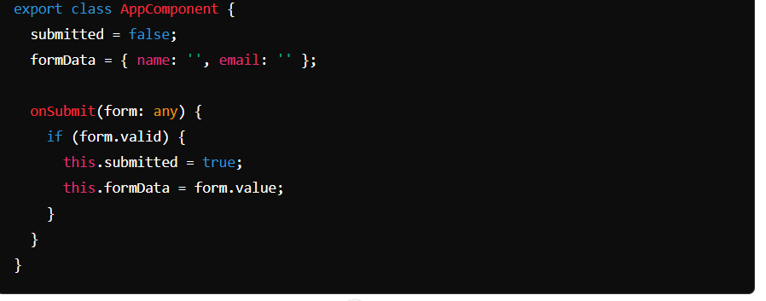

### Reactive Form

Reactive forms provide more control and flexibility by using an explicit and immutable approach to managing the form's state at a given point in time.

#### Example:

1. **app.module.ts** - Import ReactiveFormsModule:

